**1. INTRODUCTION**

Migrant Workers Unique Identification System is a system in which every citizen of a country will have a unique Identification Number which would not just help the government track down individuals who migrate across the sates in search of job, but would make life far easier for citizens as they would not have to submit multiple documents each time they want to avail a new service public private, government., regulatory authority or law-enforcement agency. This system will contain details like the name, sex, address, marital status, photo, identification mark and Blood group details. The details regarding his UID (Commonly called AADHAR) is also added to his personal details

The unique identification number will be based on a sophisticated application called SCOSTA, a secured electronic device that’s used for keeping data & other info in a way that only authorized persons can view it. The system’s database is built by collecting data from different existing databases distributed all over the country, combining and storing it in one centralized system database helping to develop a card which can be centrally issued and used everywhere. This document tells us about the benefits and capabilities that will be provided to the identification system. It also states the various requirements, specifications, advantages and constraints that the system should abide by. system helps in managing a single number for every person needs in his/her life span i.e. the number is used as Driving license number, Voter ID card number, registration number in any organization, bank account number, personal or professional details. Security mechanism in one wonders - if there is no physical Identity card or electronic smart card, then how will this system validate its citizens. For implementing this, two different processes have to followed, the first one being the recording process and the second one - the authentication process.

**2. SYSTEM ANALYSIS**

The most important reason for the proposal of the system is that, there exist no efficient system that will make identification of the migrant workers easier. Since India is a very large country in its size, and has an enormous population people from different states migrate across the states in search of job. The existing system demands only any identification card from the employees. They might give fake information regarding there details. Thus the existing system makes many drawbacks.

**2.1 Purpose:**

## Migrant workers contribute to growth and development in their countries of destination, while countries of origin greatly benefit from their remittances and the skills acquired during their migration experience. Yet, the migration process implies complex challenges in terms of governance, migrant workers' protection, migration and development linkages, and international cooperation. The works to forge policies to maximize the benefits of labor migration for all those involved.

## 2.2 Existing System

Currently, the medical works are based on the manual process, and each work is maintained in the paper. The details of purchasing drugs, audits, sell reports maintained on the paper while anyone can enter into the system and can make changes in these reports, so it is not a safe method to keep the information on the paper. The pharmacist faces problem in searching the products from the self as it is not an easy method to remember about the place of each medicine. There no Pharmacy Management System which can alert the pharmacist about the end of the drugs.

### 2.2.1 Problem in existing system

* Even though the workers submit multiple documents for providing details regarding their identity, they cannot be actually verified.
* Workers may be exploited by the employers by not returning the documents to them.
* Criminal background of the employees are not known to common man.
* Provided details are not included to a searchable database.

### 2.2.2 Solution of these problems

* Reliability: The project performs intended function with required precision; hence this project is very reliable.
* Feasibility: The project maintenance is very easy and modifications can be made in the existing system in future. All data will locate as centralized.
* Online Processing: The online processing of the project is very simple following the existing manual method without changes and suitable validation is provided for the easy and correct access of users.
* Security: Security measures are taken to avoid mishandling of database. Password restrictions are provided to enter into database. A correct password only will access to the database.

## 2.3 Proposed System

Migrant Workers Unique Identification System is a system in which every citizen of a country will have a unique Identification Number which would not just help the government track down individuals who migrate across the sates in search of job, but would make life far easier for citizens as they would not have to submit multiple documents each time they want to avail a new service public private, government., regulatory authority or law-enforcement agency. This system will contain details like the name, sex, address, marital status, photo, identification mark and Blood group details. The details regarding his UID (Commonly called AADHAR) is also added to his personal details

The unique identification number will be based on a sophisticated application called SCOSTA, a secured electronic device that’s used for keeping data & other info in a way that only authorized persons can view it. The system’s database is built by collecting data from different existing databases distributed all over the country, combining and storing it in one centralized system database helping to develop a card which can be centrally issued and used everywhere. This document tells us about the benefits and capabilities that will be provided to the identification system. It also states the various requirements, specifications, advantages and constraints that the system should abide by. system helps in managing a single number for every person needs in his/her life span i.e. the number is used as Driving license number, Voter ID card number, registration number in any organization, bank account number, personal or professional details. Security mechanism in one wonders - if there is no physical Identity card or electronic smart card, then how will this system validate its citizens. For implementing this, two different processes have to followed, the first one being the recording process and the second one - the authentication process.

### 2.3.1 Advantages of proposed system

* Centralized system for providing the unique identification for migrant workers
* Prevent men from outside the nation from working in unorganized sector
* Criminal backgrounds are noted.
* Well defined search Database is included.
* Exploitation of workers may be reduced.
* Once if lost, workers can easily make the card available in one touch access.

# 

# 3. FEASIBILITY STUDY

Feasibility analysis is a system proposal according to its workability, impact on the organization, ability to meet client and user needs and efficient use of resources. It is most necessary and prudent to evaluate the feasibility of the project at the earliest possible time. The key considerations that are involved in the feasibility analysis are,

## 3.1 Economic Feasibility

Economic analysis is the most frequently used method for evaluating the effectiveness of the candidate system. More commonly known as cost/benefit analysis, the procedure is to determine the benefits and savings that are expected from a candidate system; otherwise further alterations will have to be made, if it is to a chance of approved. The proposed system is cost effective because of its experimental and user-friendly interface. The user can directly view and change the record.

The analysis raises financial or economical question during the preliminary investigation to estimate the following.

* The benefits in the form of reduced costs or fewer costly errors.
* The cost of hardware and software for the class application of the project being considered

## 3.2 Technical Feasibility

This study is carried out to check the technical feasibility that is the technical requirements of the system. Any system developed must not have a high demand on the available technical resources. This will lead to high demand on the available technical resources. The developed system must have a modest requirement as only minimal or null changes are required for implementing this system. In National Defense Academy project works in PYTHON and uses backend SQLITE Server. The technical possibility of proposed system is as follows:

* The unit does process the hardware as well as related software for this project.
* The proposed system does not require much technical details.
* The current manual working is not so much sufficient.
* It is just requiring window operating system.

**3.3 Behavioral Feasibility**

It centres on the reaction of the users. Since the system is user-friendly, user training is an easy matter. Any one, with the basic knowledge of computer can operate the system. The users need not have prior knowledge of PYTHON 4. REQUIREMENT SPECIFICATION

## 4.1 Hardware Requirements

|  |  |
| --- | --- |
| Machine | : Pentium 4 |
| Mother Board | : 810 Intel Chipset |
| Memory | : 512 Mb Ddr2 |
| Hard Disk | : 2 Gb |
| Floppy Drive | : 1.44 Fdd |
| Dvd Writer | : 20x Dvd |
| Monitor | : 17" Colour Monitor |
| Front End | : HTML, CSS, JavaScript |
| Ide | : Sublime Text |

## 4.2 Software Requirements

Back End : Sqlite3 , Django

Operating System : Microsoft Windows 10

### 4.3 Programming Environment

An operating system is a collection of programs that control the operations of the purpose of obtaining an effective performance. It acts as an interface between hardware and user programs. It facilitates the execution of the programs. Operating system is software responsible for allocating resources including memory, processor time, disk space and peripheral device such as printers, modems and the monitor.

**4.4 Operating System Features**

### WINDOWS 10

Windows 10 is a computer operating system by Microsoft as part of its Windows family of operating systems. It was known as Threshold when it was being developed and announced at a press event on 30 September 2014. It came out for PCs on July 29, 2015. Beginning on that day, Windows 10 was available as a free upgrade for users running Windows 7 and Windows 8.1 for one year.

Windows 10 is designed to provide a common, "universal" user interface for various systems. These include desktop, laptop, and all-in-one PCs, tablet computers, smartphones, and embedded systems such as the Xbox game console. Unlike earlier versions of Windows, Windows 10 is regularly updated with new features based on user feedback, including before it was first released. Microsoft releases updates every half a year, an example of the software as a service principle. Each release has fourdigit. Build number (a type of version number), the first two digits referring to the year of release, and the other two digits referring to the month of release.

#### 4.5 Language Features

As a programming language, the features of Python brought to the table are many. Some of the most significant features of Python are:

### • Easy to Code

Python is a very developer-friendly language which means that anyone and everyone can learn to code it in a couple of hours or days. As compared to other object-oriented programming languages like Java, C, C++, and C#, Python is one of the easiest to learn.

### • Open Source and Free

Python is an open-source programming language which means that anyone can create and contribute to its development. Python has an online forum where thousands of coders gather daily to improve this language further.

Along with this Python is free to download and use in any operating system, be it Windows, Mac or Linux.

### • Support for GUI

GUI or Graphical User Interface is one of the key aspects of any programming language because it has the ability to add flair to code and make the results more visual. Python has support for a wide array of GUIs which can easily be imported to the interpreter, thus making this one of the most favourite languages for developers.

### • Object-Oriented Approach

One of the key aspects of Python is its object-oriented approach. This basically means that Python recognizes the concept of class and object encapsulation thus allowing programs to be efficient in the long run.

### • High-Level Language

Python has been designed to be a high-level programming language, which means that when you code in Python you don’t need to be aware of the coding structure, architecture as well as memory management.

### • Integrated by Nature

Python is an integrated language by nature. This means that the python interpreter executes codes one line at a time. Unlike other object-oriented programming languages, we don’t need to compile Python code thus making the debugging process much easier and efficient. Another advantage of this is, that upon execution the Python code is immediately converted into an intermediate form also known as byte-code which makes it easier to execute and also saves runtime in the long run.

### • Highly Portable

Suppose you are running Python on Windows and you need to shift the same to either a Mac or a Linux system, then you can easily achieve the same in Python without having to worry about changing the code. This is not possible in other programming languages, thus making Python one of the most portable languages available in the industry.

### Highly Dynamic

As mentioned in an earlier paragraph, Python is one of the most dynamic languages available in the industry today. What this basically means is that the type of a variable is decided at the run time and not in advance. Due to the presence of this feature, we do not need to specify the type of the variable during coding, thus saving time and increasing efficiency.

### • Extensive Array of Library

Out of the box, Python comes inbuilt with a large number of libraries that can be imported at any instance and be used in a specific program. The presence of libraries also makes sure that you don’t need to write all the code yourself and can import the same from those that already exist in the libraries.

### • Support for Other Languages

Being coded in C, Python by default supports the execution of code written in other programming languages such as Java, C, and C#, thus making it one of the versatile in the industry.

**4.6 Software Tools Used**

The whole Project is divided in two parts the front end and the back end.

### Front end

The front end is designed using of Python, HTML, CSS, and JavaScript.

**Python:**

Python is an easy to learn, powerful programming language. It has efficient high-level data structures and a simple but effective approach to object-oriented programming. Python’s elegant syntax and dynamic typing, together with its interpreted nature, make it an ideal language for scripting and rapid application development in many areas on most platforms.

Each rule begins with a name (which is the name defined by the rule) and: =. A vertical bar (|) is used to separate alternatives; it is the least binding operator in this notation. A star (*) means zero or more repetitions of the preceding item; likewise, a plus (+) means one or more repetitions, and a phrase enclosed in square brackets ([ ]) means zero or one occurrences (in other words, the enclosed phrase is optional). The * and + operators bind as tightly as possible; parentheses are used for grouping. Literal strings are enclosed in quotes. White space is only meaningful to separate tokens. Rules are normally contained on a single line; rules with many alternatives may be formatted alternatively with each line after the first beginning with a vertical bar.

In lexical definitions (as the example above), two more conventions are used: Two literal characters separated by three dots mean a choice of any single character in the given (inclusive) range of ASCII characters. A phrase between angular brackets (<...>) gives an informal description of the symbol defined; e.g., this could be used to describe the notion of ‘control character’ if needed.

Even though the notation used is almost the same, there is a big difference between the meaning of lexical and syntactic definitions: a lexical definition operates on the individual characters of the input source, while a syntax definition operates on the stream of tokens generated by the lexical analysis. All uses of BNF in the next chapter (“Lexical Analysis”) are lexical definitions; uses in subsequent chapters are syntactic definitions.

**HTML:**

HTML or Hyper Text Markup Language is the main markup language for creating web pages and other information that can be displayed in a web browser.HTML is written in the form of HTML elements consisting of tags enclosed in angle brackets (like <html>), within the web page content. HTML tags most commonly come in pairs like <h1> and </h1>, although some tags represent empty elements and so are unpaired, for example:<img> The first tag in a pair is the start tag, and the second tag is the end tag (they are also called opening tags and closing tags). In between these tags web designers can add text, further tags, comments and other types of text- based content. The purpose of a web browser is to read HTML documents and compose them into visible or audible web pages. The browser does not display the HTML tags, but uses the tags to interpret the content of the page.HTML elements form the building blocks of all websites. HTML allows images and objects to be embedded and can be used to create interactive forms. It provides a means to create structured documents by denoting structural semantics for text such as headings, paragraphs, lists, links, quotes and other items. It can embed scripts written in languages such as JavaScript which affect the behavior of HTML web pages.

**CSS:**

Cascading Style Sheets (CSS) is a style sheet language used fordescribing the look and formatting of a document written in a markup language. While most often used to style web pages and interfaces written in HTML and XHTML, the language can be applied to any kind of XML document, including plain XML, SVG and XUL. CSS is a cornerstone specification of the web and almost all web pages use CSS style sheets to describe their presentation.CSS is designed primarily to enable the separation of document content from document presentation, including elements such as the layout, colors, and fonts. This separation can improve content accessibility, provide more flexibility and control in the specification. of presentation characteristics, enable multiple pages to share formatting, and reduce complexity and repetition in the structural content (such as by allowing for table less web design).CSS can also allow the same markup page to be presented in different styles for different rendering methods, such as on-screen, in print, by voice (when 14 read out by a speech-based browser or screen reader) and on Braille-based, tactile devices. It can also be used to allow the web page to display differently depending on the screen size or device on which it is being viewed. While the author of a document typically links that document to a CSS file, readers can use a different style sheet, perhaps one on their own computer, to override the one the author has specified. However, if the author or the reader did not link the document to a specific style sheet the default style of the browser will be applied.CSS specifies a priority scheme to determine which style rules apply if more than one rule matches against a particular element. In this so-called cascade, priorities or weights are calculated and assigned to rules, so that the results are predictable.

**JavaScript:**

JavaScript (JS) is a dynamic computer programming language. It is most commonly used as part of web browsers, whose implementations allow client-side scripts to interact with the user, control the browser, communicate asynchronously, and alter the document content that is displayed. It is also being used in server-side programming, game development and the creation of desktop and mobile applications. JavaScript is a prototype- based scripting language with dynamic typing and has first-class functions. Its syntax was influenced by C. JavaScript copies many names and naming conventions from Java, but the two languages are otherwise unrelated and have very different semantics. The key design principles within JavaScript are taken from the Self and Scheme programming languages. It is a multiparadigm language, supporting object-oriented, imperative, and functional programming styles. The application of JavaScript to use outside of web pages—for example, in PDF documents, site-specific browsers, and desktop widgets—is also significant. Newer and faster JavaScript VMs and platforms built upon them (notably Node.js) have also increased the popularity of JavaScript for server-side web applications. On the client side, JavaScript was traditionally implemented as an interpreted language but just-in- time compilation is now performed by recent (post-2012) browsers.

### Back end

SQLite3 is a compact free database you can use easily create and use a database. Though SQLite3 is not a full- featured database, it supports a surprisingly large set of the SQL standard, and is *ideal for those just starting to learn SQL* as well for developers that need a simple database engine to plug into their applications. As such, SQLite has become very popular with smart phone developers.

**SQLite3 Benefits**

#### Small and Self-Contained

* No additional programs or components are required for it to run. The database engine can run on any modern PC or Smartphone
* SQLite doesn’t require a separate computer process to run. IT doesn’t rely on windows services, background daemons, nor separate computer hardware. • It is simple to install and use.

#### Portable

* It is really simple to share databases. Just copy one file to do so. This is what makes it easy for me to provide you with the essential SQL sample database.
* A SQLite database file is at home on Windows as much as it is OS X.

### 4.7 PROJECT MODULES

Modules are:-

* 1. Admin
  2. Authority
  3. User

**Modules Description:**

**Admin Module**

The administrator may be otherwise the super administrator, which is implemented by the providing a pre-determined user name and password for the administrator. The administrator is who has all the ultimate powers for every action that can be performed in the system. The admin approves the authorities registered in the system also the users registered. The admin can add or remove any data from the system or any person from the system.

**Authority Module**

The authorities get enrolled to the system by applying online. They might fill the application form provided and will be approved by the administrator. The authorities will have a dashboard where the user registration to his location or the police station may be listed down

The authorities approve and makes the ID card to the employees with the QR code. The card will be sent to the users manually. The authorities has all the powers except to approve another authority registration and to remove any detain the system. The authority also has the authentication to search and find someone. The authority provides an NOC and uploads the pdf file to the system. He also specifies the criminal activity index of the person that will be marked in these card

**User Module**

A new user has to register in the system by filling all the details that are been need by the system. The details will include a unique username and the password. Thus if the user has to wait till he gets the approval from the authority

This system will contain details like the name, sex, address, marital status, photo, identification mark and Blood group details. The details regarding his UID (Commonly called AADHAR) is also added to his personal details. This details can be made used for searching the employees and finding them. The approval might take a long time since all the data need a clarification.

**5.SYSTEM DESIGN**

The most creative and challenging phase of system life cycle is system design. The term design describes a final system and the process by which it is developed. It refers to the technical specifications that will be applied in implementing the candidate system. The elegant design achieves its objectives with minimum use of resources. The first step is to determine how the output is to be produced and in what format. The input and the database have to be designed to meet the requirements of proposed output.

## 5.1 Data Flow Diagram

Larry Constantine first developed the DFD as a way of expressing system requirements in a graphical form this led to module design. A dataflow diagram DFD also known as a "bubble chart" is a graphical technique that depicts information and transforms that are applied as data move from input to output. The DFD is used to represent increasing information flow and functional details.

A DFD consist of a series of bubbles joined by lines. The bubbles represent data flows in the system.A level-0 DFD is also called a fundamental system model represents the entire software elements as a single bible with input and output indicated by incoming and outgoing arrows respectively. Additional process and information flow parts are represented in the next level, i.e., level 1 DFD. Each of the process represented at level 1 are sub functions of overall system depicted in the context model. Any processes that are complex in level 1 level will be further represented into sub functions in the next level, i.e., level 2.

Data flow diagrams is a means of representing a system at any level of detail with a graphic network of symbols showing data flows, data stores, data process and data stores. The purpose of data flow diagram is to provide a semantic bridge between users and system developers. The diagram is graphical, eliminating thousands of words, logical representations, modelling what system does; hierarchical, showing systems at any level of details; and jargon less, allowing user understanding and reviewing. The goal of data flow diagramming is to have a commonly understood model of a system.

The diagram is the basis of the structural analysis. Data flow diagrams are supported by other techniques of structured system analysis data structured diagram, data dictionaries and procedure representing techniques such as decision tables, decision tree and structured English. Processes represent activities in which data is manipulated by being retrieved or transformed in some way. A circle represents it. The process will show the data transformation or change. Data coming into a process must be “worked-on” or transformed in some way. Thus, all process may have an input and output.

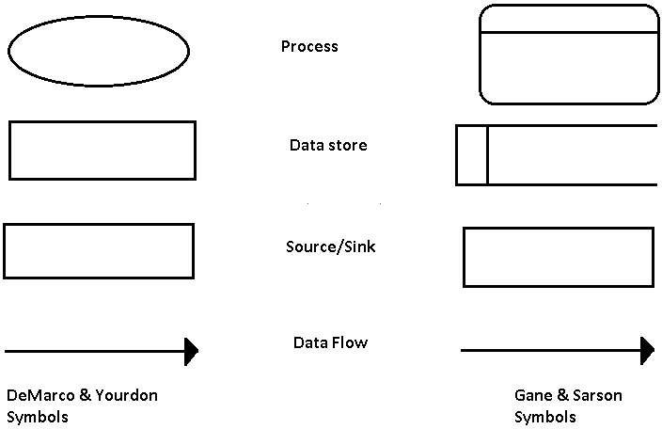

* **Context Diagram**

Migrant worker unique identification System

ADMIN

AUTHORITY

USER

ADMIN DFD

Login

Check credent ials

Manage module s

Add/remove the data

Verify application of user

Manage users

Manage authority

Admin

Authority DFD

Login

Check

credentials

Manage modules

Upload pdf and mark

Search & find user

Provide NOC

Approve & generate ID card

Make QR code

Authority

Verify application of user

Manage users

USER DFD

Login

Migrant worker unique identification ion

Download ID card

Edit profile

Apply to id card

User

Entity- Relationship diagram (ERD)

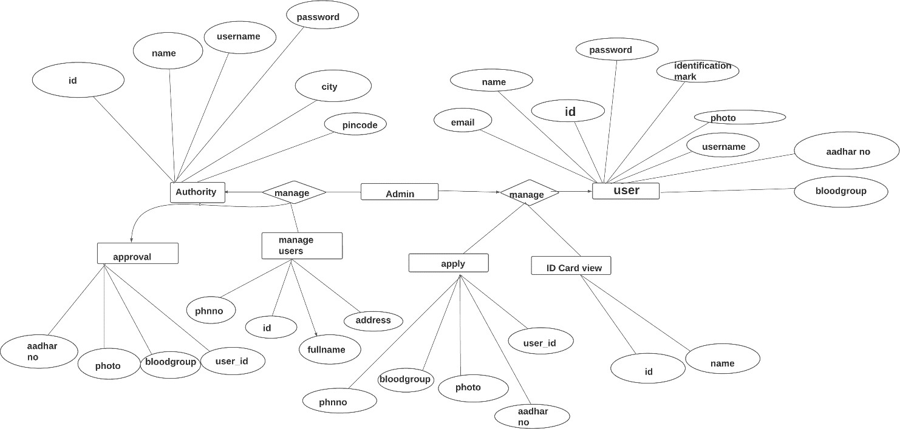

**4. DATABASE DESIGN**

The overall objectives in the development of database technology has been to treat data as an organizational resource and as an integrated whole Database Management System allow the data to be protected and organized separately from other resources. If Database Management System can provide centralized access to the data from the Programs, it is possible to treat the data as separate resource. The objectives of Database design are,

* Data integration

* Data abstraction

* Data independence

Several degrees of normalization have to be applied during the process of table design. The major aim of the process of normalization is to reduce data redundancy and Prevent losing data integrity. Redundancy refers to unwanted and unnecessary repetition of data.Data integrity has to be converted at all levels. For normalization can create problems related to storage and retrieval of data. During the process of normalization, dependencies can be identified which cause serious problems during deletion and updating. Normalization also helps in simplifying the structure of tables. The theme behind a database is to handle the information as an integrated whole thus making access to information easy, quick, inexpensive and flexible for the users. The entire package depends on how the data is maintained in the system. Each table has been designed with a perfect vision. Minor tables have been created which through takes much space facilities for the purpose of querying fast and accurately.

The tables used in this project are described below

**4.1 TABLE DESIGN**

### 1. Authority

|  |  |  |  |  |
| --- | --- | --- | --- | --- |
| **Field Name** | **Data Type** | **Size** | **Constraints** | **Description** |
| username | char field | 200 | Not null | username |
| email | email field | 70 | Not null | email field |
| district | char field | 200 | Not null | district |
| mobile | char field | 200 | Not null | mobile number |
| password | Char field | 200 | Not null | password |

### 2. Worker

|  |  |  |  |  |
| --- | --- | --- | --- | --- |
| **Field Name** | **Data Type** | **Size** | **Constraints** | **Description** |
| username | char field | 200 | Not null | username |
| email | email field | 70 | Not null | email field |
| district | char field | 200 | Not null | district |
| mobile | char field | 200 | Not null | mobile number |
| status | char field | 200 | Not null | status |
| aplcn | char field | 200 | Not null | application |
| password | Char field | 200 | Not null | password |
| First name | char Field | 200 | Not Null | first name |
| Last name | Char field | 200 | Not null | Last name |
| gender | Char field | 200 | Not null | Gender |
| address | Char field | 200 | Not null | address |
| Marital status | Char field | 2 | Not null | Marital status |
| photo | Image field |  |  | photo |
| Identification mark | Char field | 200 | Not null | Identification mark |
| Blood group | Char field | 200 | Not null | Blood group |
| Uid adhar or driving license number | Char field | 200 | Not null | Uid adhar or driving license number |
| mwuid | Char field | 200 | Not null | Migrant workers unique id |

**4.2 USER INTERFACE DESIGN**

I/O design forms one of the major aspects of any system design. It requires much careful attention towards the user side. It defines the interface between user and system. Carefully designed input and output define how effective the system is.

* **INPUT DESIGN**

Input design converts user-oriented inputs to computer-based formats, which requires careful attention. The collection of input data is the most expensive part of the system in terms of the equipment used and the number of people involved. In input design, data is accepted for computer processing and input to the system is done through mapping via a map support or links. Inaccurate input data is the most common cause of errors in data processing. The input screens need to be designed more carefully and logically. A set of menus is provided which help for better application navigation. While entering data in the input forms, proper validation checks are done and messages will be generated by the system if incorrect data has been entered.

* **OUTPUT DESIGN**

Outputs are the most important and useful information to the user and to the department. Intelligent output designs will improve systems relationships with the user and help much in decision-making. Outputs are also used to provide a permanent hard copy of the results for later use.

**5 .SCREEN LAYOUTS**

**HOME PAGE**

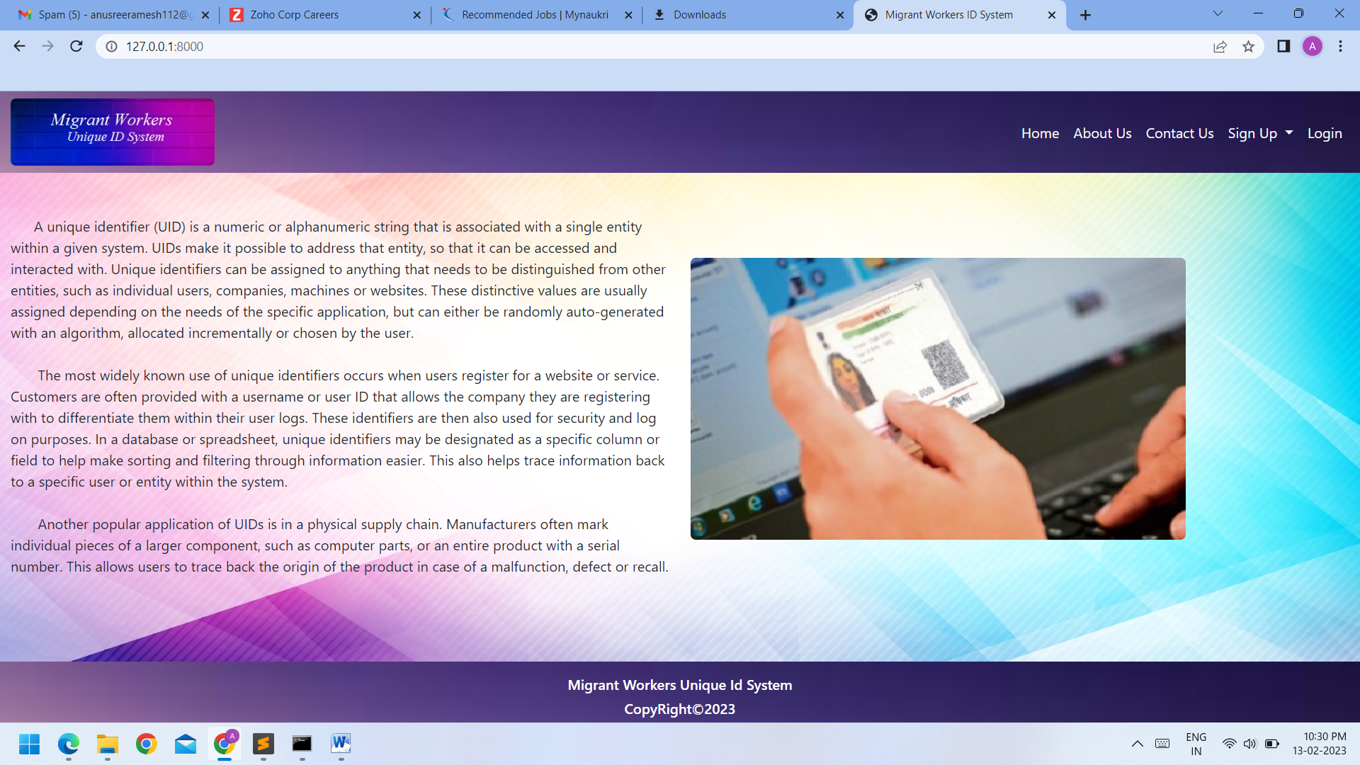

**AUTHORITY REGISTRATION PAGE**

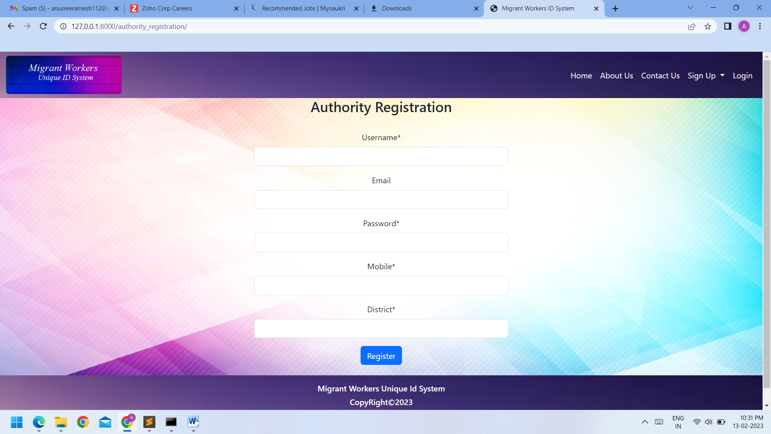

**USER REGISTRATION PAGE**

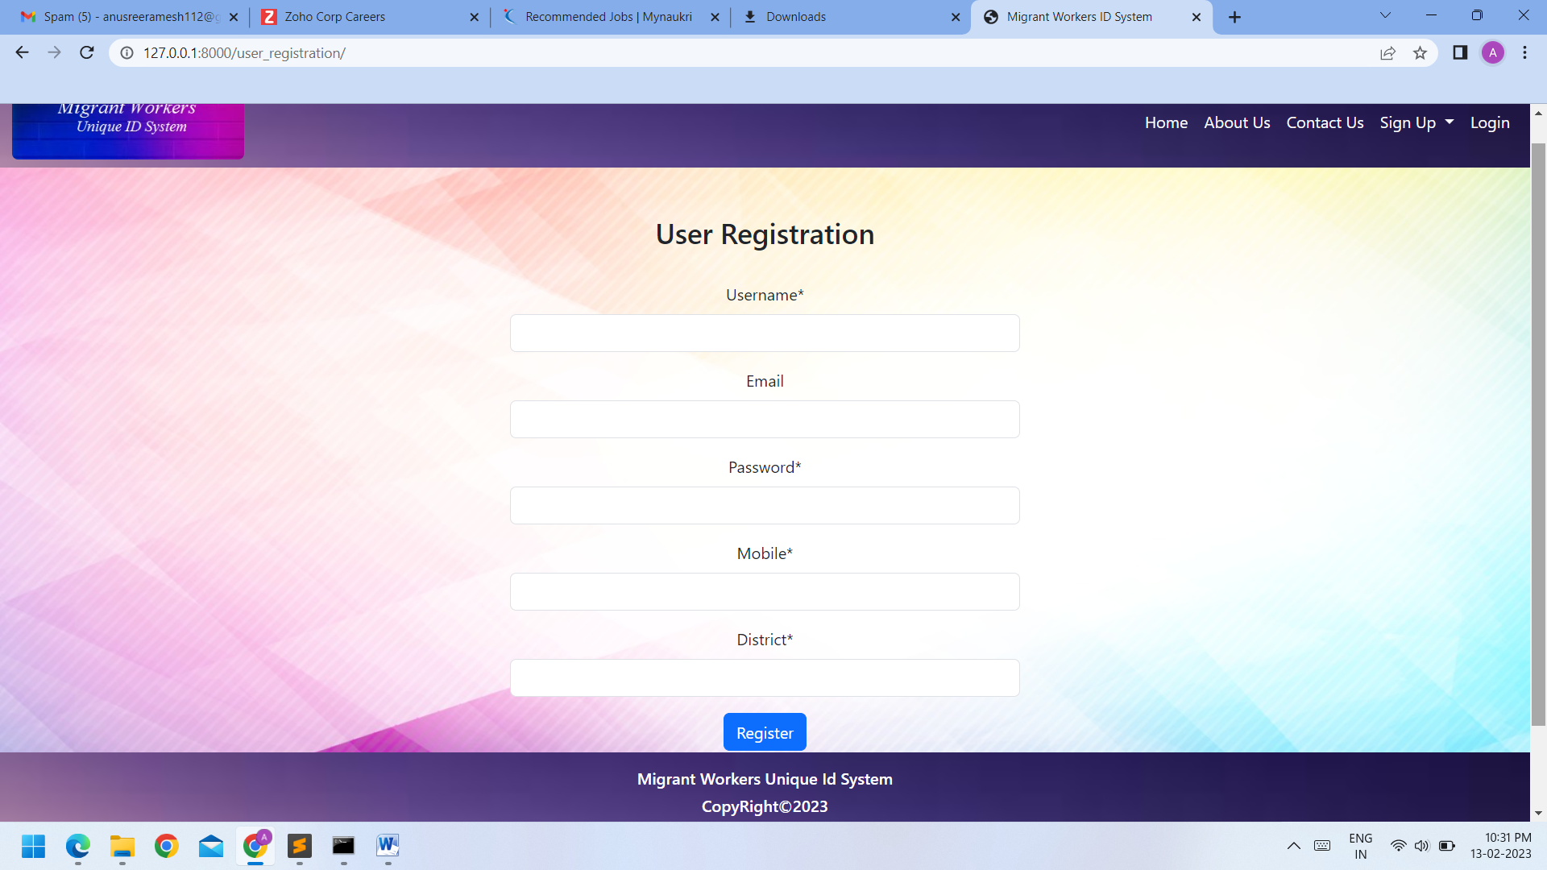

**LOGIN PAGE**

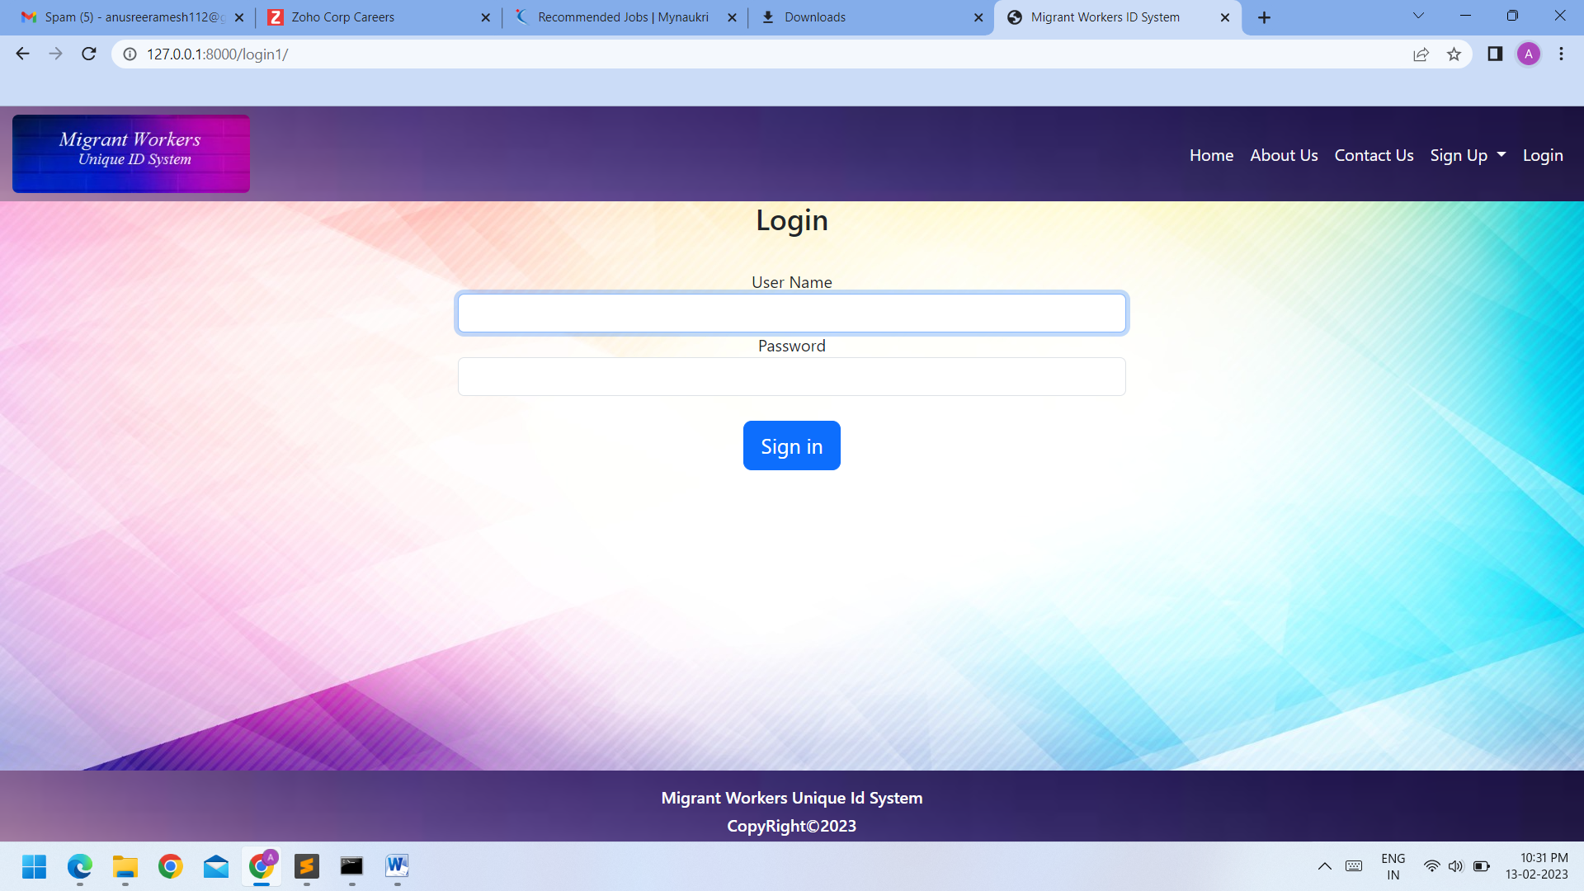

## AUTHORITY HOME PAGE

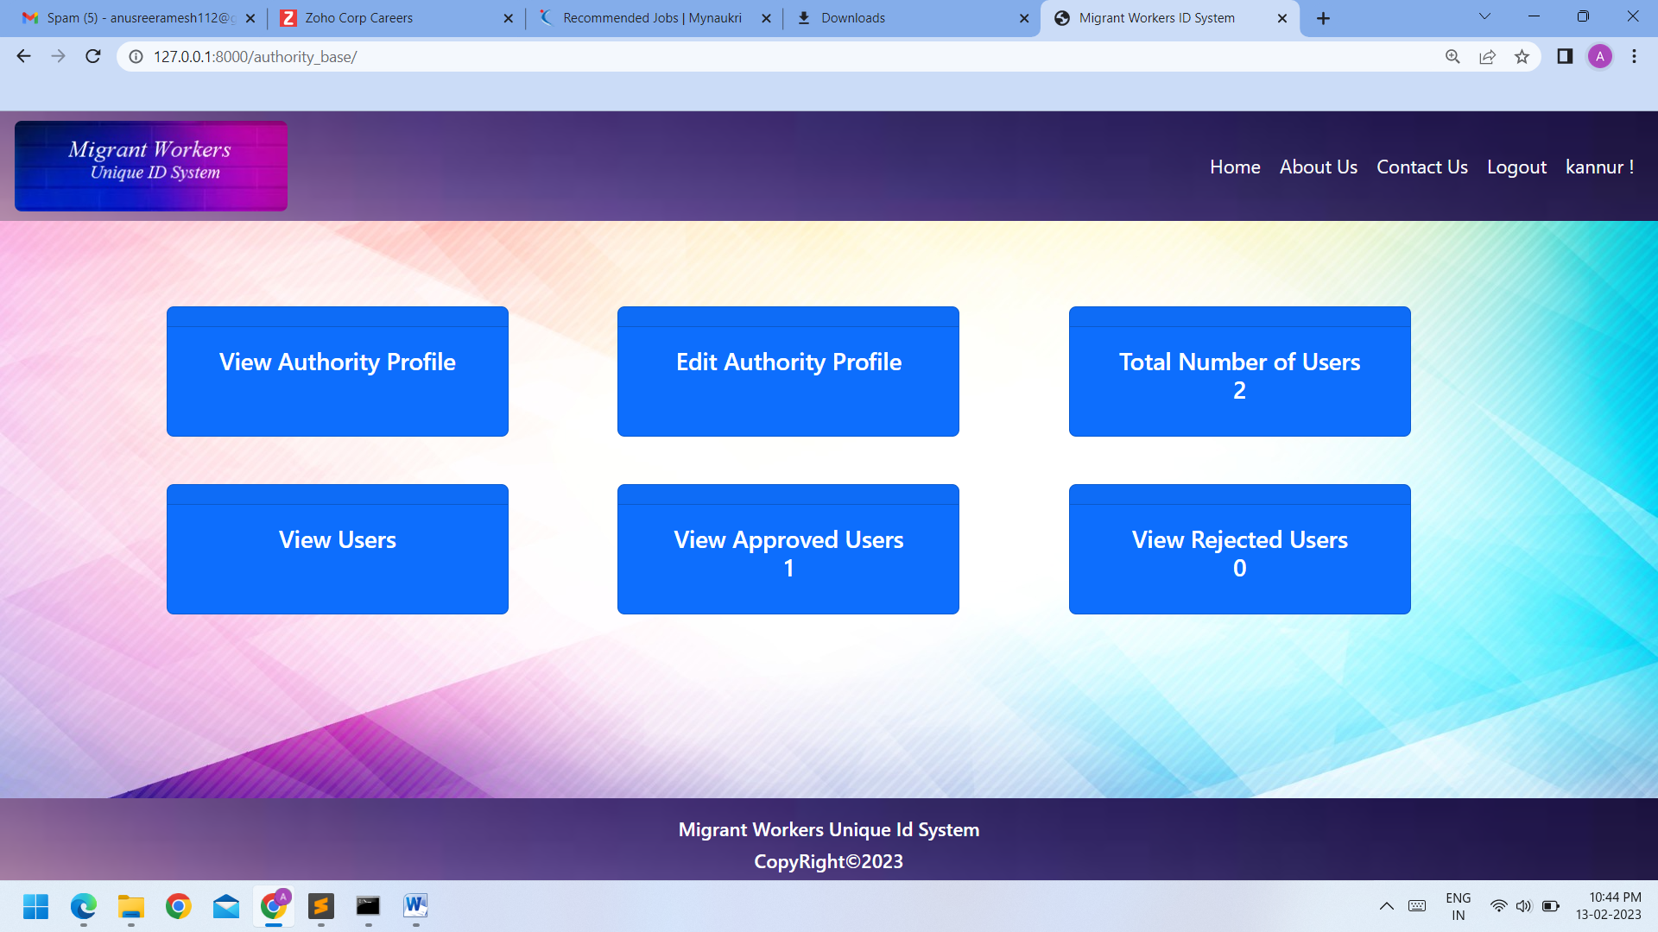

**AUTHORITY VIEW PROFILE PAGE**

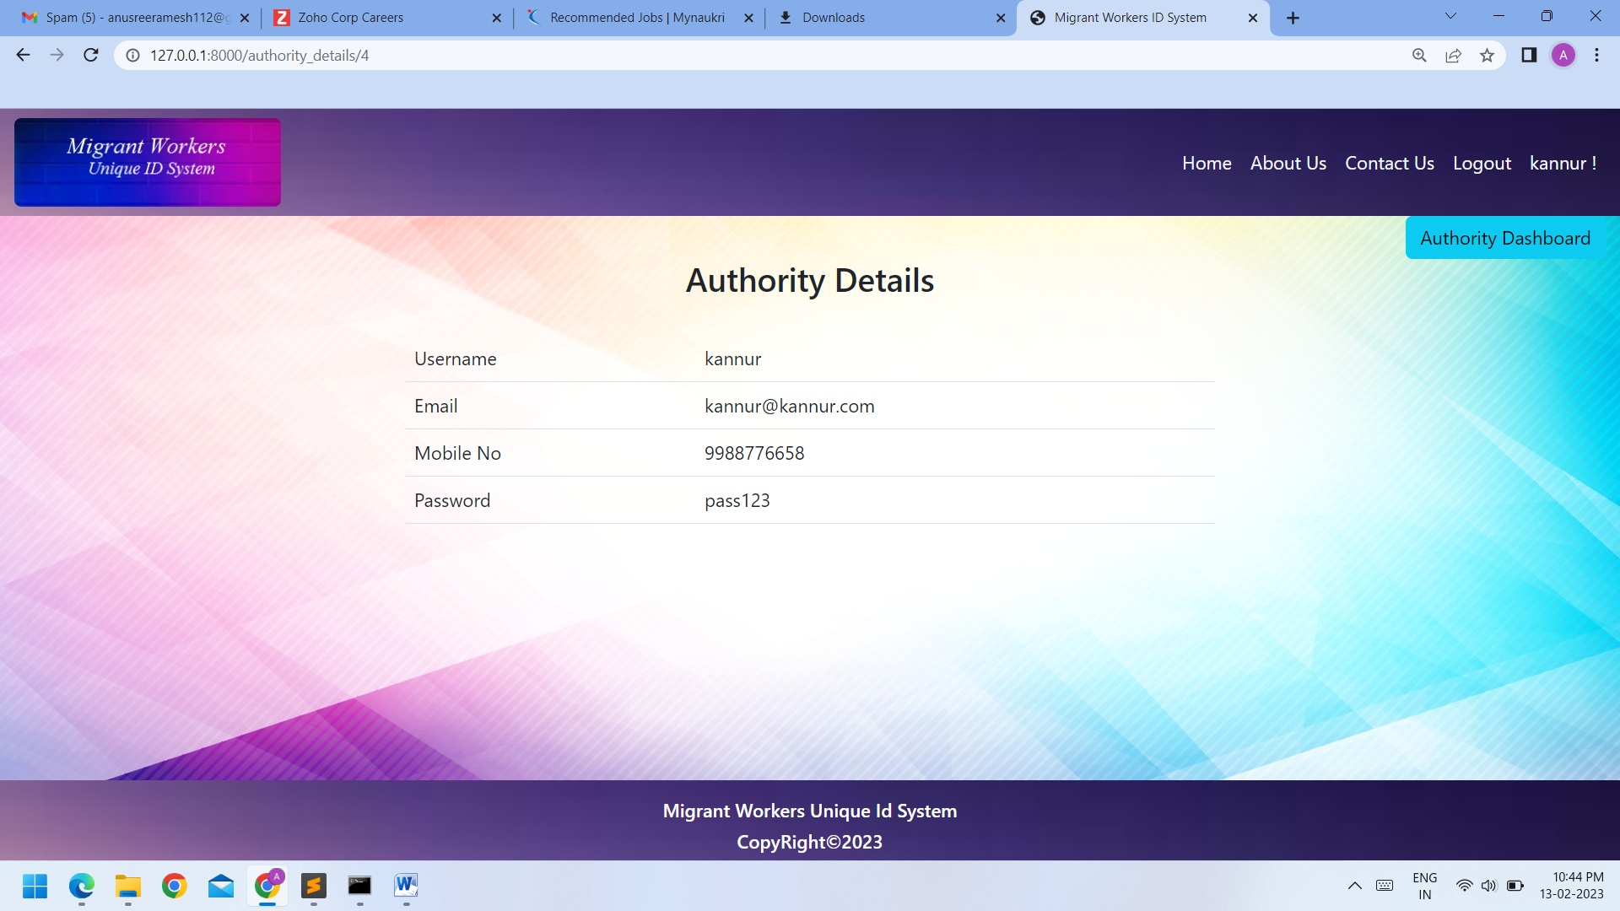

**AUTHORITY EDIT PROFILE PAGE**

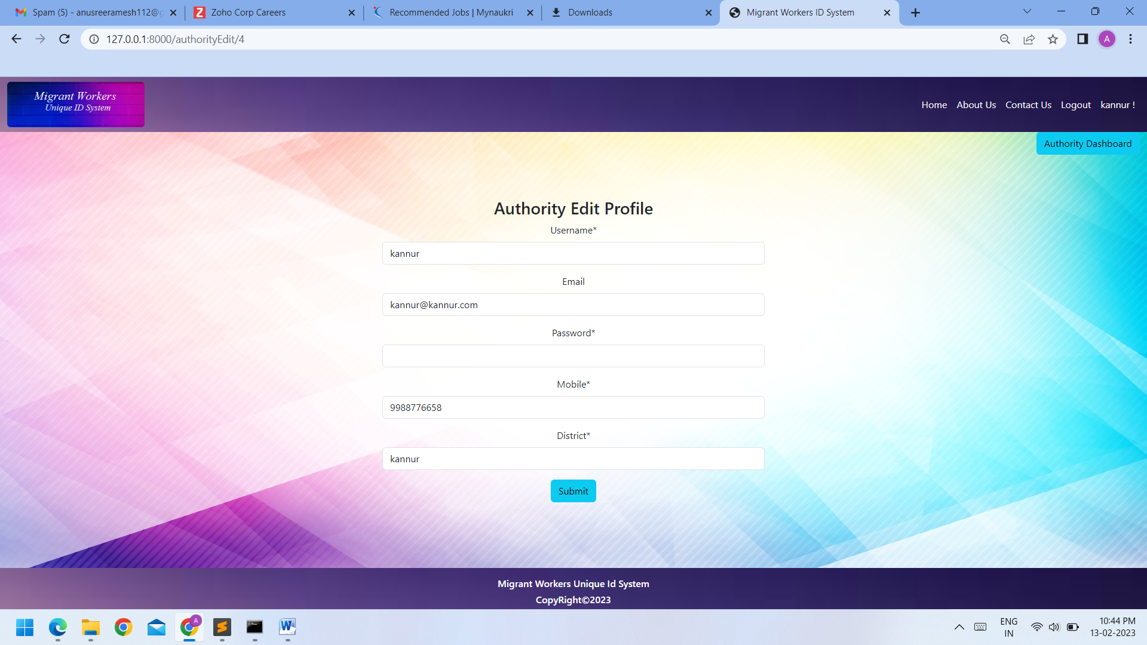

**AUTHORITY VIEW USERS LIST PAGE**

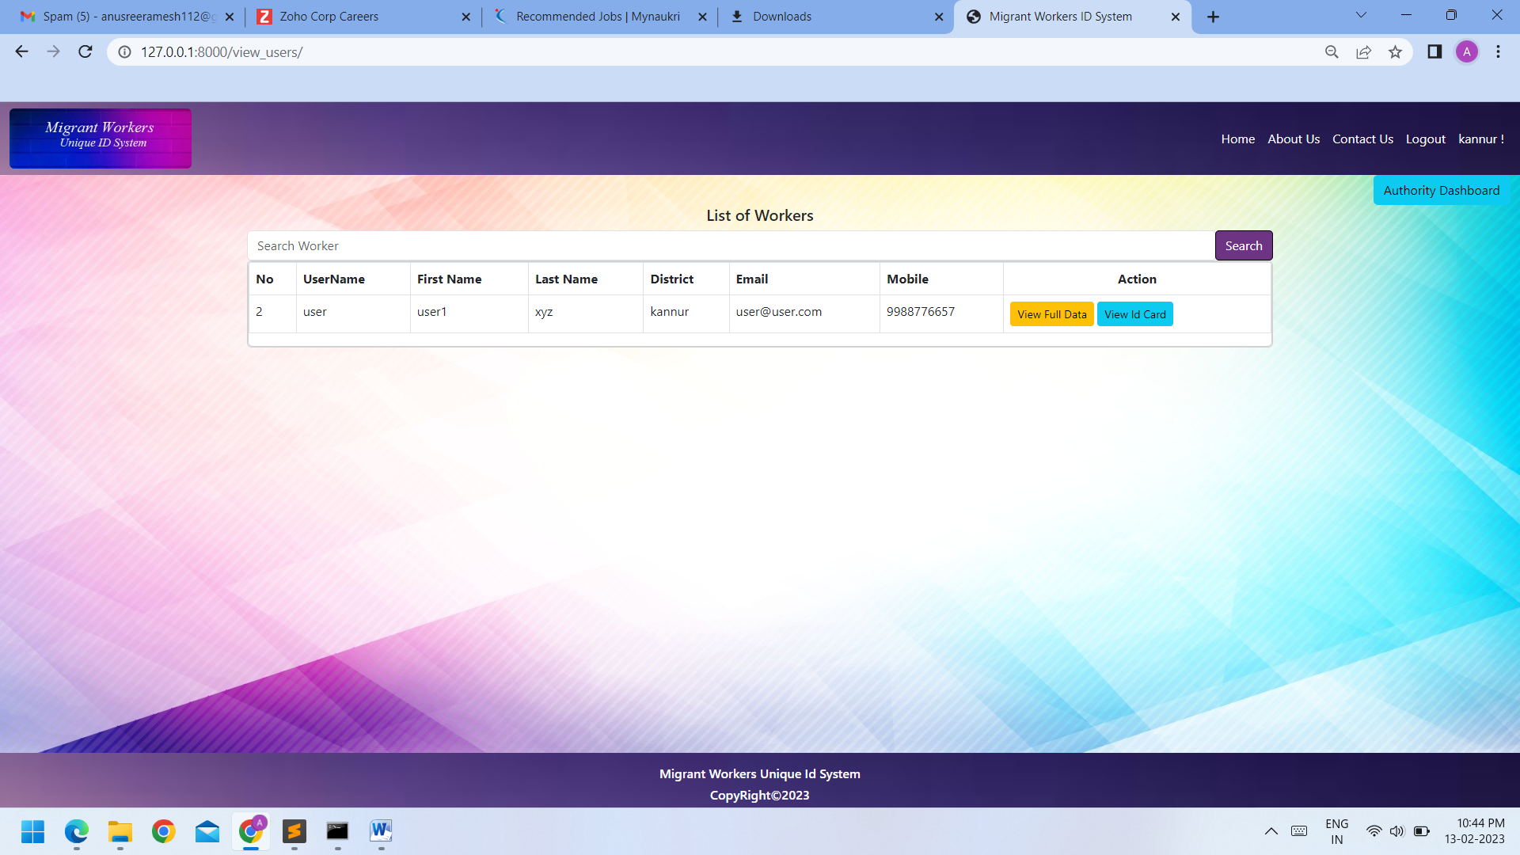

## AUTHORITY VIEW USERS APPLICATION PAGE

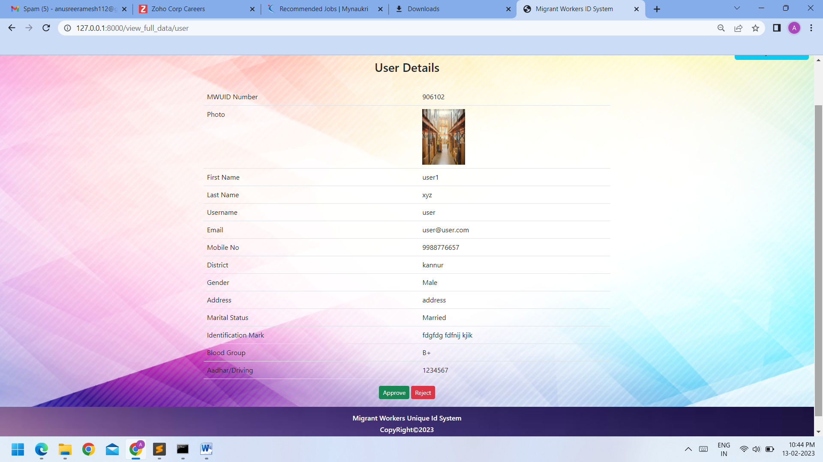

**AUTHORITY VIEW USERS ID CARD PAGE**

## 

## C:\Users\HP\Pictures\Screenshots\Screenshot (109).png

## AUTHORITY APPROVAL USERS PAGE

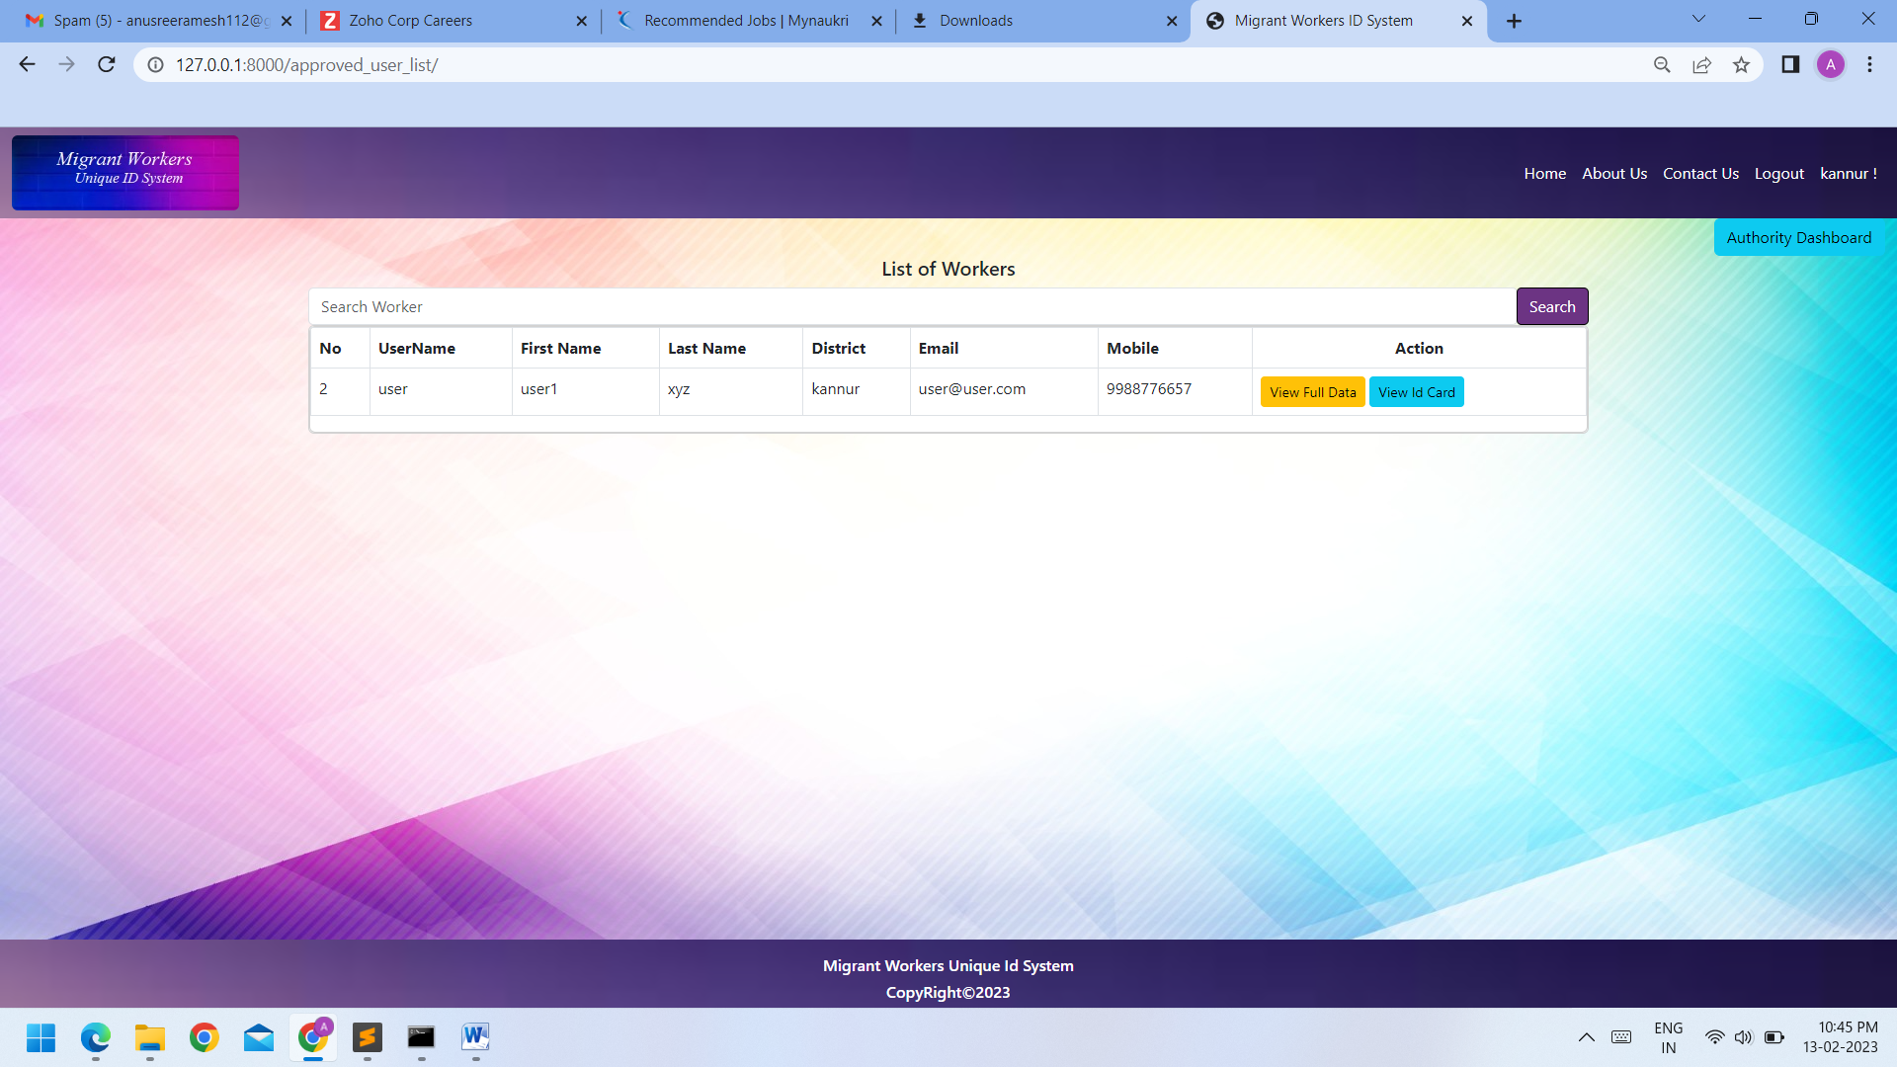

**AUTHORITY REJECTED USERS PAGE**

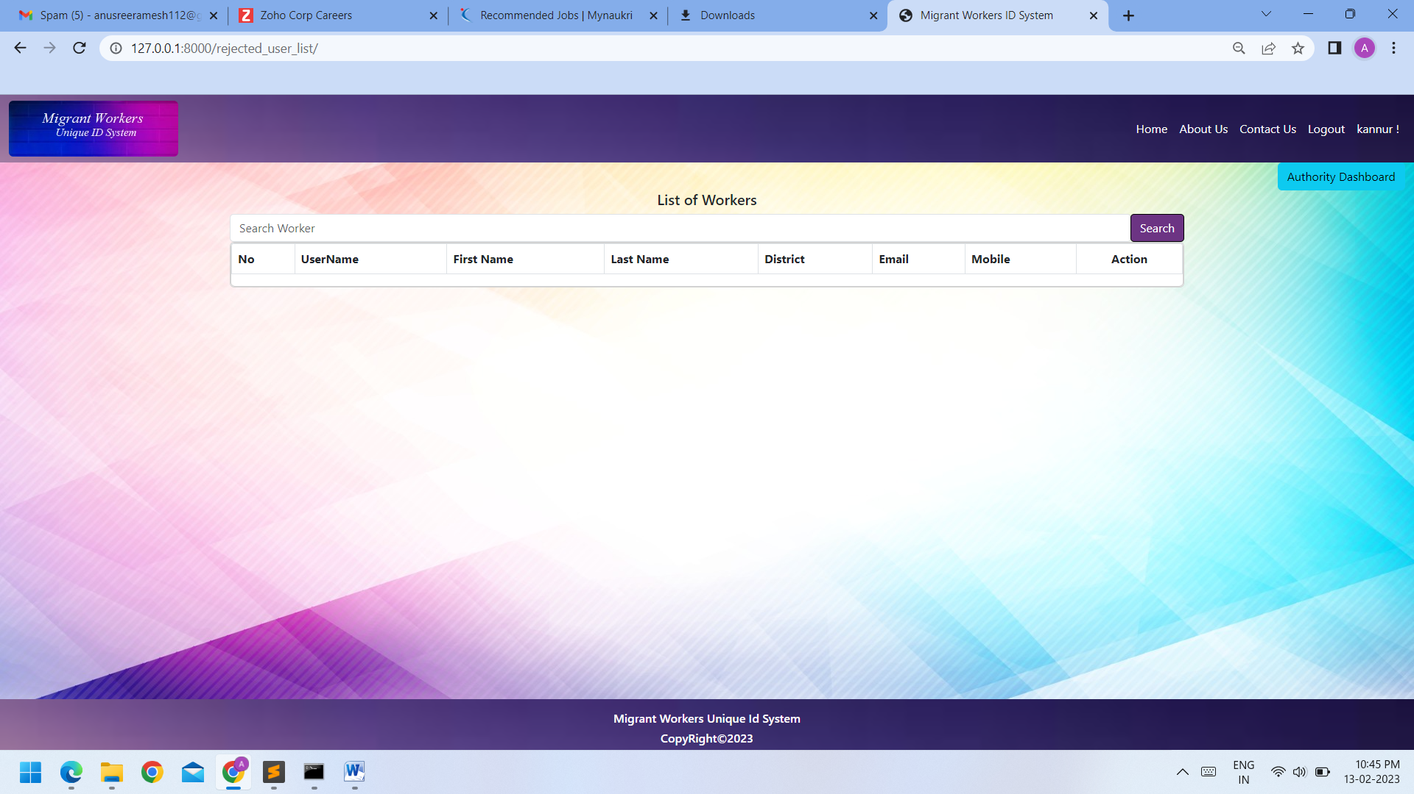

**USER DASHBOARD**

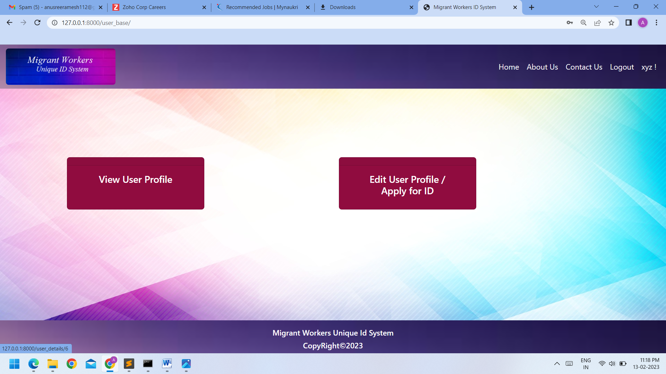

**USER VIEW PROFILE PAGE**

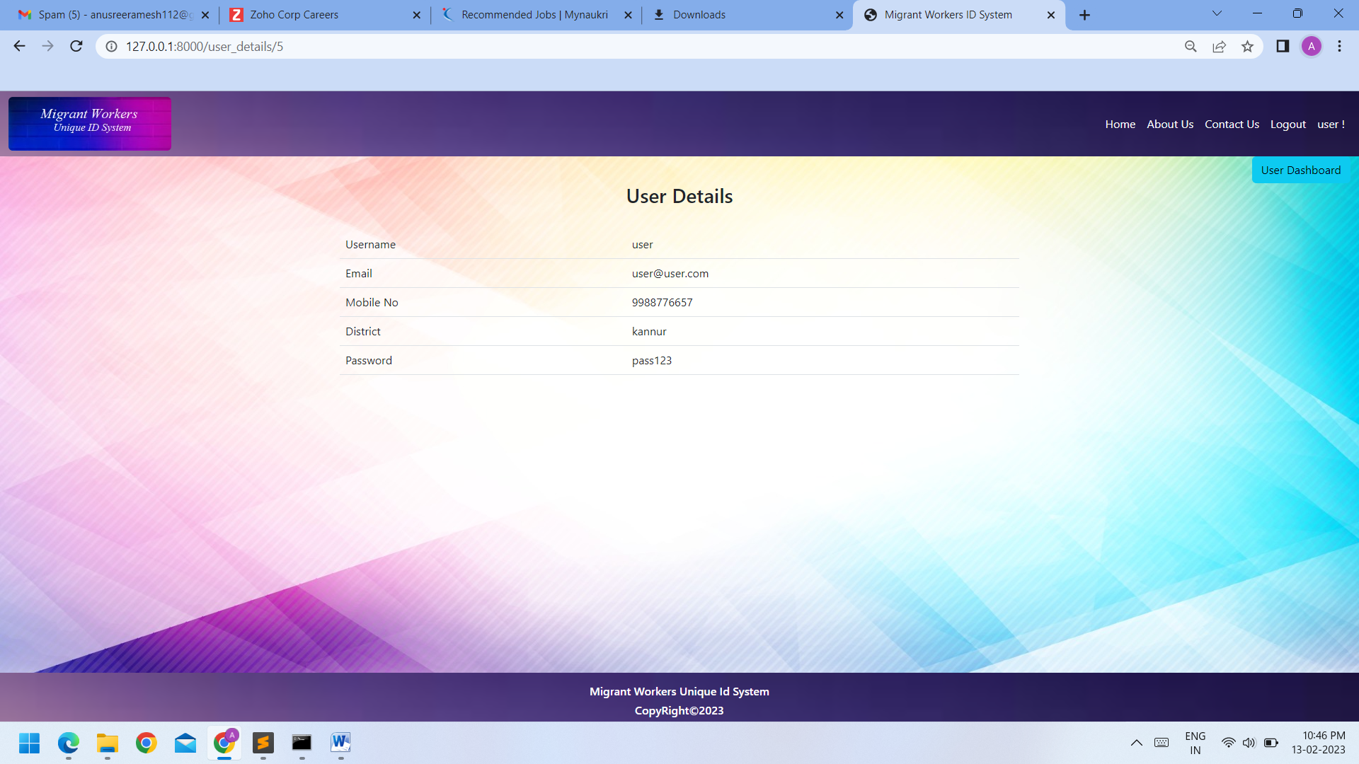

**USER APPLY PAGE**

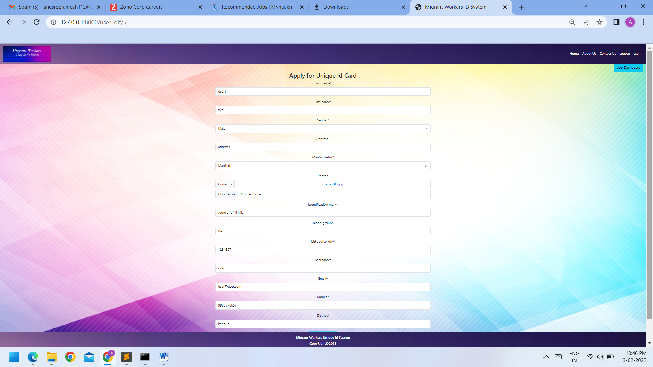

**USER DASHBOARD AFTER ID CARD APPROVED**

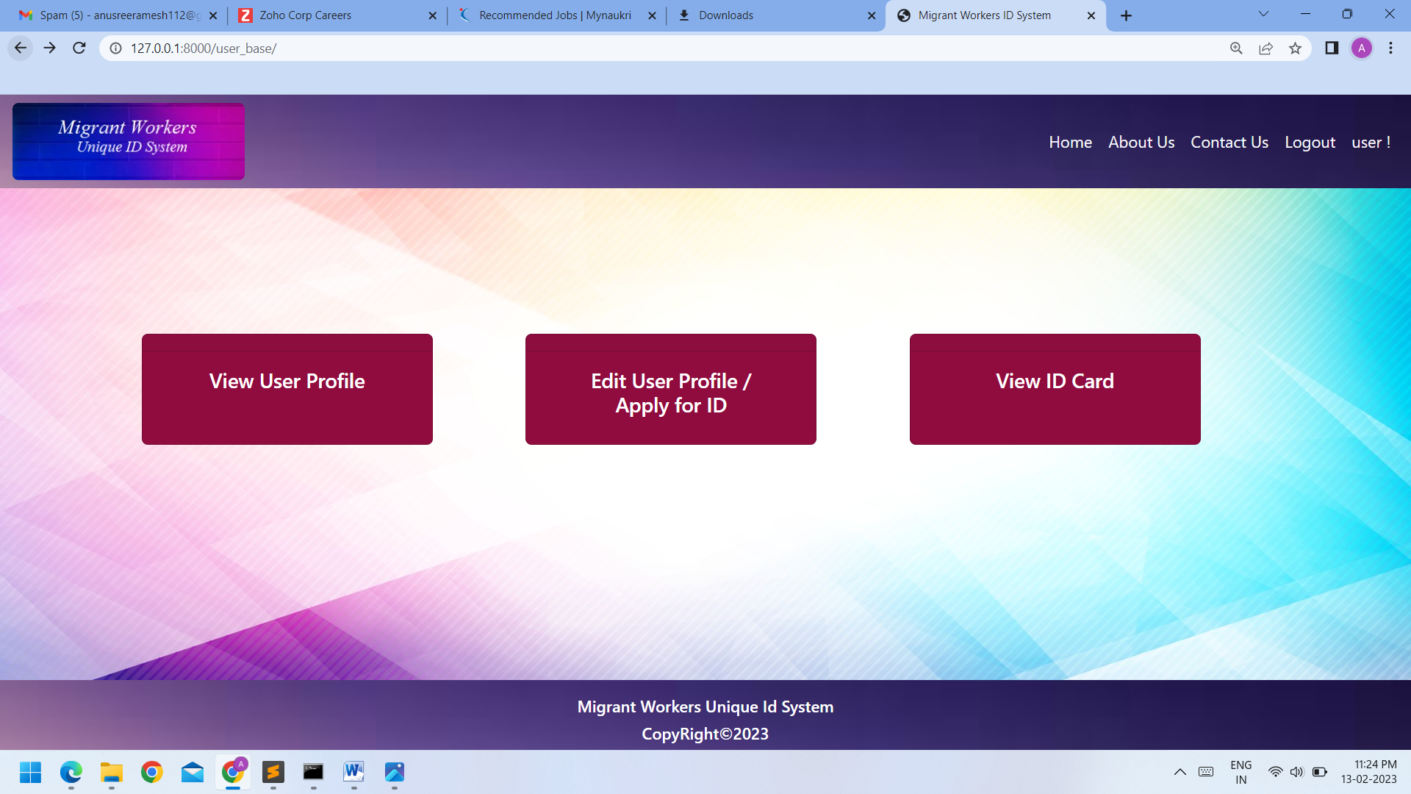

## USER VIEW ID CARD PAGE

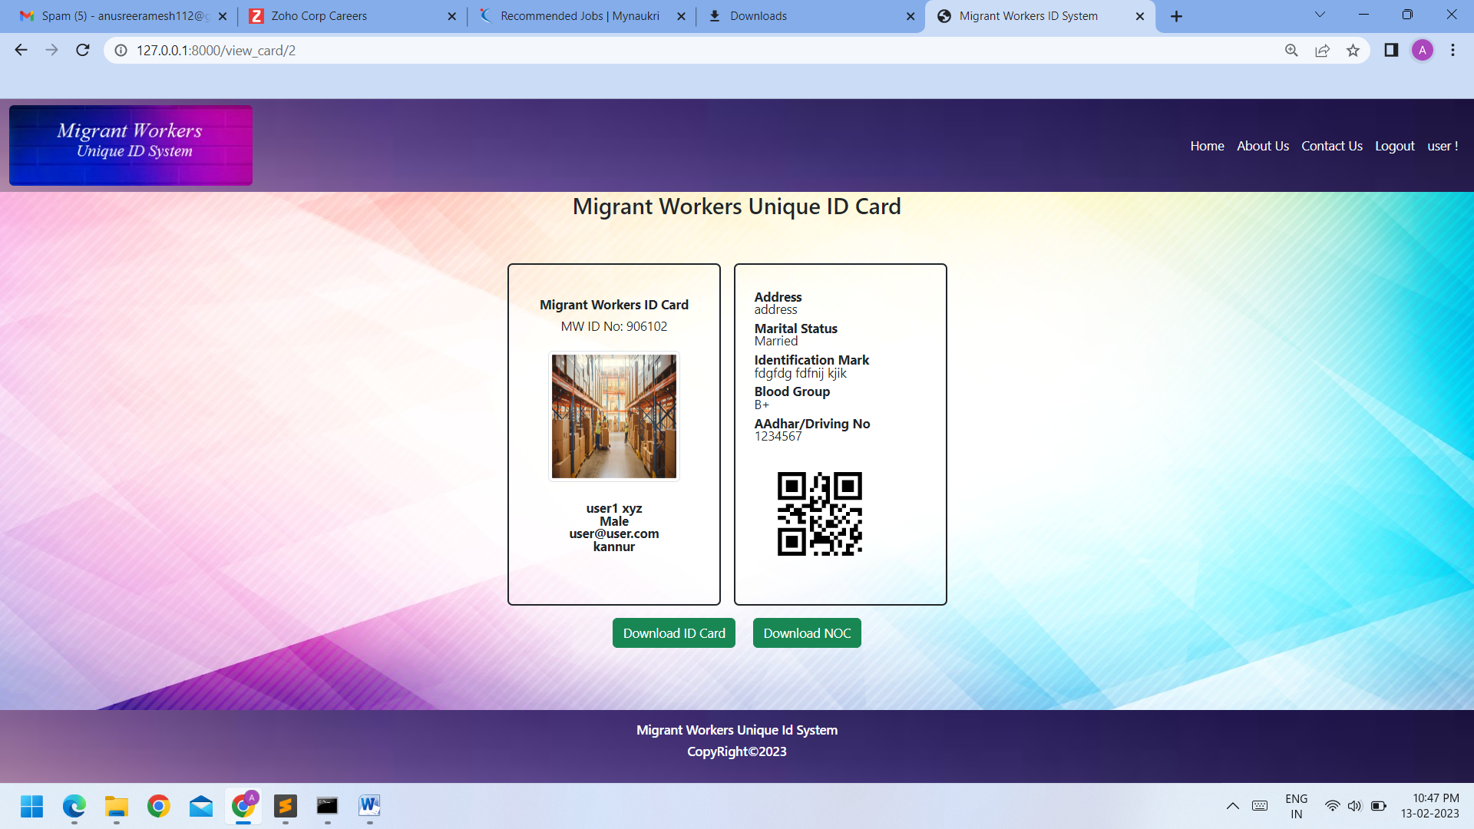

# 6. TESTING

Software testing is in critical element of the software development cycle. The testing is essential for ensuring the quality of the software developed and represents the ultimate view of specification, design and code generation. Software testing is designed as the process by which one detects the defects in the software. Testing begins at the module level and work towards the integration of entire computers-based system. A good test case is one that has a high probability of finding an as-yet undiscovered error. A successful test is one such uncovers of finds such errors. If testing is conducted successfully, it will uncover the errors in the software. It also demonstrates that software functions are being performed according to specification and also behavioral and performance requirements are satisfied. For this, test plans have to be prepared. The implementation of a computer system requires that test data have to be prepared and that the element’s is being tested in a planned and efficient manner. Nothing is complete without testing as it is vital success of the system.

**Testing objectives**

There are several rules that can serve as testing objectives. They are,

* Testing is a process of executing a program and finding a BUG.
* A good test case is one that has a high probability of finding an undiscovered error
* A successful test is one that uncovers an undiscovered error

If testing is conducted successfully according to the objectives as stated above, it would uncover errors in the software. Also testing demonstrates that software functions appear to the working according to the specification that performance requirements appear to have been met. The four stages of testing are,

❖ Unit testing

* Integrated testing
* System testing
* Validation testing

## 

## 6.1 Unit Testing

This testing strategy considers the concept of unit changes. The focus on the algorithmic details of a module and the data flow across the module interface. Each module in ‘Revenue Recovery and Tax Processing System’ is considered as separate unit. The input given and output generated by each module is studied separately. Every possibility of input that can be supplied is considered. Unit testing focuses verification effort on the smallest unit of software designs the module. To check whether each module in the software works properly so that it gives desired outputs to the given inputs. All validations and Conditions are tested in the module level in the test. Control paths are tested to ensure the information properly flows into, out of the program under test. Boundary condition is tested to ensure that the module operates at boundaries, establishes that it restricts processing. All independent paths through the control structure ensure that all statements in a module have been executed at least once. In conclusion, all errors handling paths are tested.

## 6.2 Integration Testing

This testing strategy combines all the modules involved in the system. After the independent modules are tested, dependent modules that use the independent modules are tested. This sequence of testing layers of dependent module continues until the entire system is constructed. Through each program works individually, they should work after linking them together. This is also referred to as interfacing. Data may be lost across interface and one module can have an adverse effect on another. Subroutines, after linking, may not do the desired function expected by the main routine. Integrated testing is a systematic technique for constructing program structure while at same time, conducting test to uncover errors associated with the interface. In the testing, the programs are constructed and tested in small segments.

## 6.3 Final System Testing

This is a final step in testing. In this, the entire system was tested as a whole with all forms, code, module and class modules. This form of testing is popularly Known as Black Box testing or system testing. Black Box testing methods focus on the functional requirement of the software. That is, Black Box testing enable the software engineer to derive set of input condition that will fully exercise all functional requirements for a program. Black Box testing attempt to find errors in the following categories; incorrect missing function, interface errors.Error in data structure or external data base access, performance errors and initialization errors and termination errors. In this system, Black Box testing has been successfully handled any mistakes found are rectified and found running successfully. The test input data was given to the system and got desired output.

## 6.4 Validation Testing

Validation is basically done by the testers during the testing. While validating the product if some deviation is found in the actual result from the expected result then a bug is reported or an incident is raised. Not all incidents are bugs. But all bugs are incidents. Incidents can also be of type ‘Question’ where the functionality is not clear to the tester.Hence, validation helps in unfolding the exact functionality of the features and helps the testers to understand the product in much better way. It helps in making the product more user friendly.

Validation testing is the process of ensuring if the tested and developed software satisfies the client /user needs. The business requirement logic or scenarios have to be tested in detail. All the critical functionalities of an application must be tested here. As a tester, it is always important to know how to verify the business logic or scenarios that are given to you. One such method that helps in detail evaluation of the functionalities is the Validation Process.

Whenever you are asked to perform a validation test, it takes a great responsibility as you need to test all the critical business requirements based on the user needs. There should not be even a single miss on the requirements asked by the user. Hence a keen knowledge on validation testing is much important. Test data should be prepared carefully since the data only determine the efficiency and accuracy of the system. Artificial data are prepared solely for the purpose of every program validates the input data.

As a tester, you need to evaluate if the test execution results comply with that mentioned in the requirements document. Any deviation should be reported immediately and that deviation is thus called a bug.

Tools like HP quality Centre, Selenium, Appium, etc are used to perform validation test and we can store the test results there. A proper test plan, test execution runs, defect reports, reports & metrics are the important deliverables to be submitted.

**7.SYSTEM IMPLEMENTATION**

An import aspect of system analyst’s job is to make sure that the new design is implemented to established standard. Implementation is used here to mean the process of converting a new or a reversed system design into operational one.

There are three types of implementation,

❖ Implementation of a computer system to replace a manual system. The problems encountered are converting files, training users, creating accurate and verifying print outs for integrity

❖ Implementation of a new computer system to replace the existing one

❖ Implementation of modified application to replace an existing or, using the same computer. This type of conversion is relatively easy to handle.

**CONVERSION**

Conversion means changing from one system to another. The objective is to put the system into operation while holding costs, risks and personal irritation to a minimum. It involves

❖ Creating computer compatible files.

❖ Training the operating staff.

❖ Installing terminals and hardware

**User Training**

The analyst must have clear idea about the user’s capacity and requirement. A well designed system may fail because of the way are operated and used. So, the user must be trained before using the new system and the quality of the training must be high.

**System Security and Backup**

The implementation phase is the rollout of the production version of the system to the client community. This involves tasks like backing up the existing system, data conversions producing user documentation.

**Security**

Security is an essential part of the increased scale of computerization and the development of the system like sensitive are

**Back up**

Backups for hardware, the data and the system are inevitable factor to be considered. Data backup represents insurance against actual loss of data due to equipment malfunction, program failure or accident. Hence data can be providing on hard disk or on floppy disk.

**7.1 Documenting The System**

After the jobs of testing were completed the whole system as well documented in clear, Understandable and simple language. This was to ensure that if any updating has to be performed in the future the users would not face any difficulties in performing tasks. An acceptance was made to attain maximum perfection in documentation the software in a simple, precise and self-explanatory manner. The documentations deal with the system development with maximum clarity Each and every process is explained in details. The various tables used by the system with their fields are provided. Different types of programs denoting various activities of the system are included. The testing methods adopted also from a part of the document. The outputs generated by the system constitute another part.

**8. CONCLUSION**

Migrant Workers Unique Identification System is a system in which every citizen of a country will have a unique Identification Number which would not just help the government track down individuals who migrate across the sates in search of job, but would make life far easier for citizens as they would not have to submit multiple documents each time they want to avail a new service—public private, government., regulatory authority or law-enforcement agency. This system will contain details like the name, sex, address, marital status, photo, identification mark and Blood group details. The details regarding his UID (Commonly called AADHAR) is also added to his personal details. The unique identification number will be based on a sophisticated application called SCOSTA, a secured electronic device that’s used for keeping data &amp; other info in a way that only authorized persons can view it. The system’s database is built by collecting data from different existing databases distributed all over the country, combining and storing it in one centralized system database helping to develop a card which can be centrally issued and used everywhere. This document tells us about the benefits and capabilities that will be provided to the identification system. It also states the various requirements, specifications, advantages and constraints that the system should abide by. system helps in managing a single number for every person needs in his/her life span i.e. the number is used as Driving license number, Voter ID card number, registration number in any organization, bank account number, personal or professional details. Security mechanism in one wonders - if there is no physical Identity card or electronic smart card, then how will this system validate its citizens. For implementing this, two different processes have to followed, the first one being the recording process and the second one - the authentication process In the future location based chips can be implemented into the cards thus the location of each and every worker can be traced, which increases the security of the state. The card can be implemented with punching facilities that the workers may not be exploited at work site by making them to work for extra time. Also the card can be linked with his bank account that will make his payment easier.